**Assignment 1**

**SQA – Boot Camp**

**Muhammad Umair**

**4128**

**Website 1:** <https://demo.vuestorefront.io/>

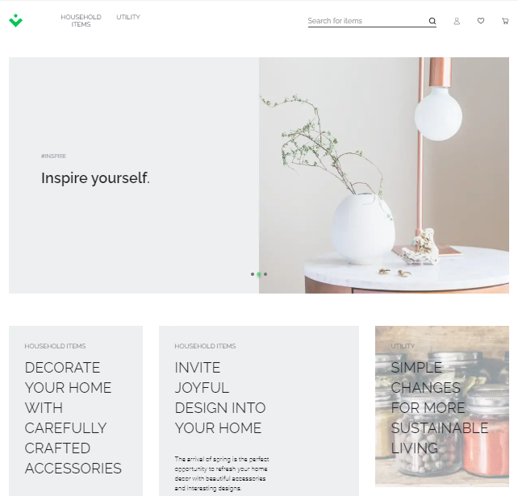

**Functional Requirements**

The given website is an Ecommerce store selling household and utility products. The main functional requirements are as follow:

1. A navigation bar for home page, my account, cart, my account.
2. On my account there is an option for registered customers and new customers.
3. A slider showing sales, new products or offers
4. Cards showing a short description and link to their category products
5. Website supports different languages (In the given its English and German)
6. Product slider: showing product pictures, prices, add to cart and an icon to mark that product in wish list or favorite).
7. A form to subscribe to store newsletter and promotional emails.
8. A footer showing link to all pages like contact us, about us, terms and conditions, my cart etc.
9. Social Media link to company social media handles.
10. On products page there is a product/sorting filter which can filter/sort different products according to price, rating, name, date added.
11. A search bar to search products.
12. On product page there is a side bar to quickly access products from that category or sub category only.
13. View icon to arrange products in list or grid view.
14. If a user wants to check a specific product and click a product page is opened
15. On product page a slider shows different images of that product.
16. Detailed title and price of product
17. A counter to add quantity of that product in cart.
18. Detailed description, Reviews and Additional Information of that product.
19. Size chart of that product and selector for different attributes like color, size.
20. At the check, out page there is a form to take different information from user like delivery address, shipping, billing and payment information from user.
21. There is a section for order summary having complete details of products which are in cart, total subtotal, Tax, Amount, Coupon and Gift field

**Suggestions / Defects**

1. There can be website name along with logo on top bar.
2. Sub categories of Household items and utilities can be included in a dropdown.
3. The text on ‘’DECORATE YOUR HOME WITH CAREFULLY CRAFTED ACCESSORIES’’ & ‘Shopping Now’ button Needs to be adjusted.
4. There is no button for utilities whereas a button is provided for house hold items category.

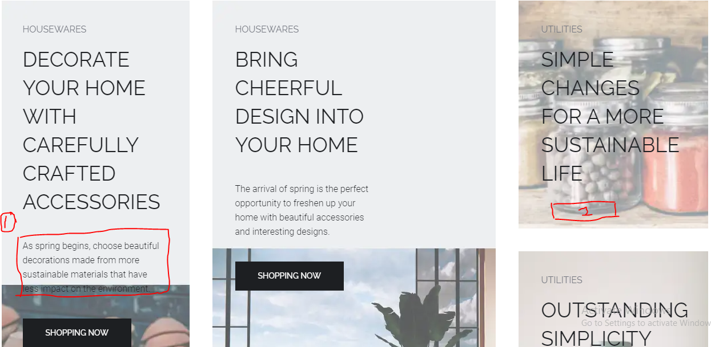

1. The add to cart button on product slider is not working properly. On clicking one time 2 items are being added in cart.
2. The text in the footer needs to be adjusted. At some points it is Starting with Uppercase and at some Lowercase.
3. All hyperlinks need to be added.
4. Along with *DISCOVER NEW PRODUCTS* slider there can be another slider of SALE or *FEATURED PRODUCTS*.
5. Contact Us needs to be mentioned.
6. On writing both wrong email and password in my account login the website do not proceed further but also don’t show any alert/error to the user.
7. While creating new user account and writing an email which is not authenticate like ([bfjdj//bc@gmail.com](mailto:bfjdj//bc@gmail.com)) the website shows error *Request failed with status code 422* . \
8. While creating a new user account with an email which doesnot belong to me the website allowed me to create an account as there is no verification of email. By this anyone can create a profile with wrong email

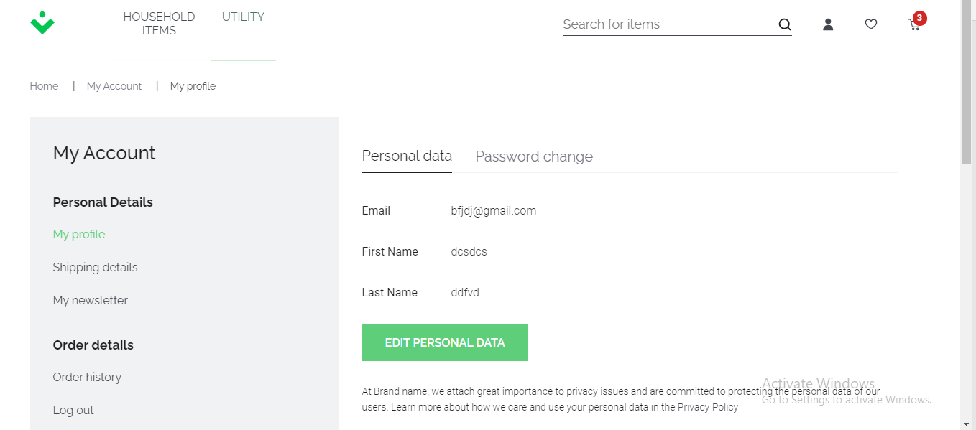

**Website 2:** <https://demoblaze.com/index.html>

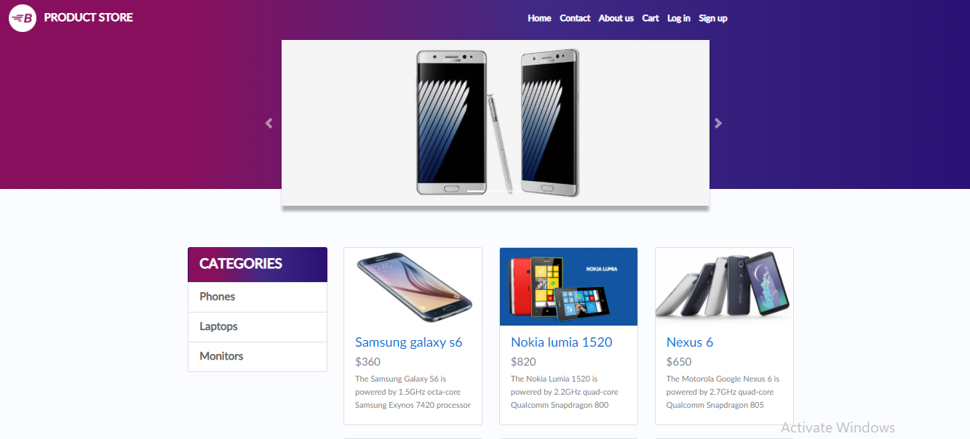

**Functional Requirements**

The given website is an Ecommerce store selling laptops, mobiles and monitors. The main functional requirements are as follow:

1. A navigation bar containing link to Home, Contact Us, About Us Cart, log in and sign up almost all the main pages.
2. A logo showing name of website.
3. Hero Section contacting a gradient background and slider showing different products like laptop, phones.
4. A side bar containing all categories.
5. Under hero section and slider there are some featured products along with their prices, pictures.
6. A *Next* and *Previous* button to load more products.
7. Below it there is footer which contains About Us text, Contact Information and site logo.
8. If we click on product a product page opens up which contains product Title , Product Description, Add to cart button.

**Suggestions / Defects**